Please follow below procedure in order.

First extract then install boost by running bootstrap and then b2 files in boost folder.Be patient.

Then change settings in visual studio according to below pictures by replacing red rectangles with your location.

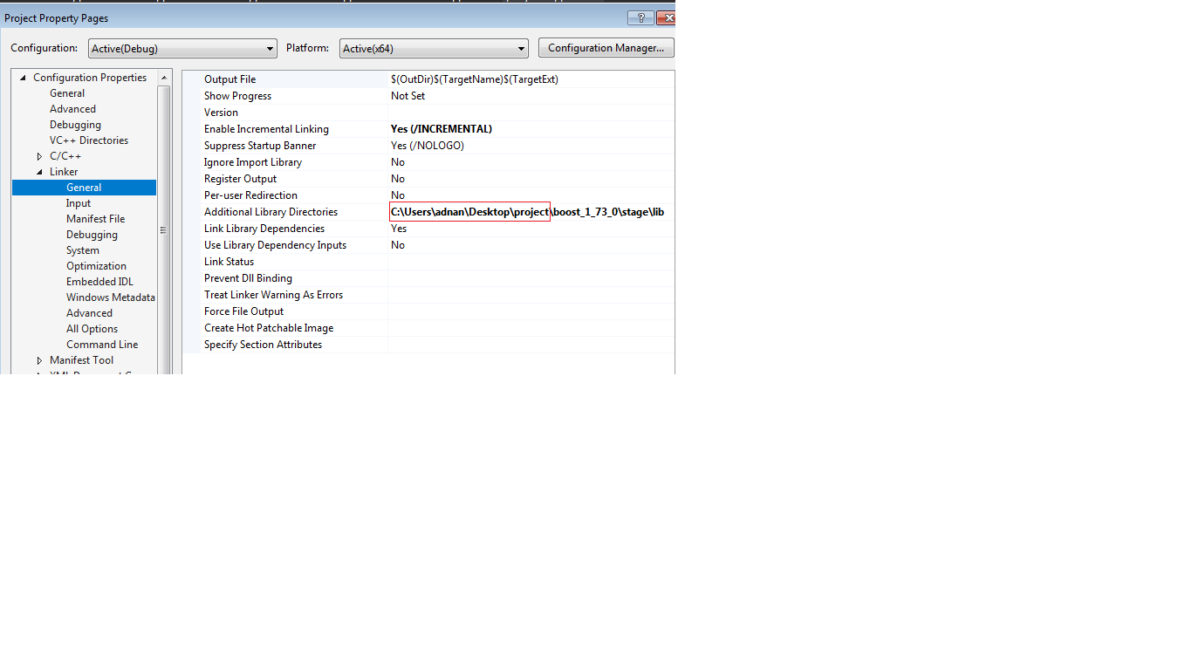

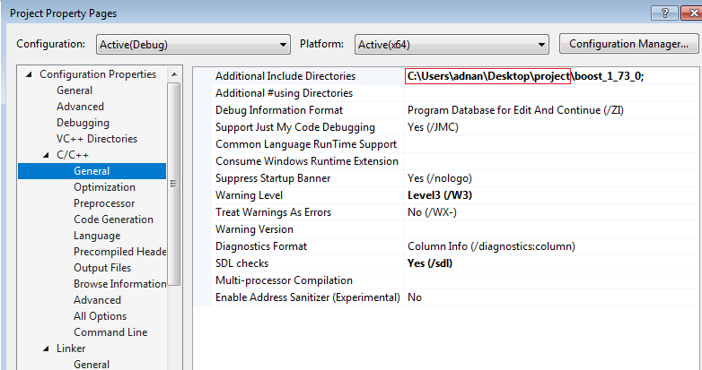

You can start program now.